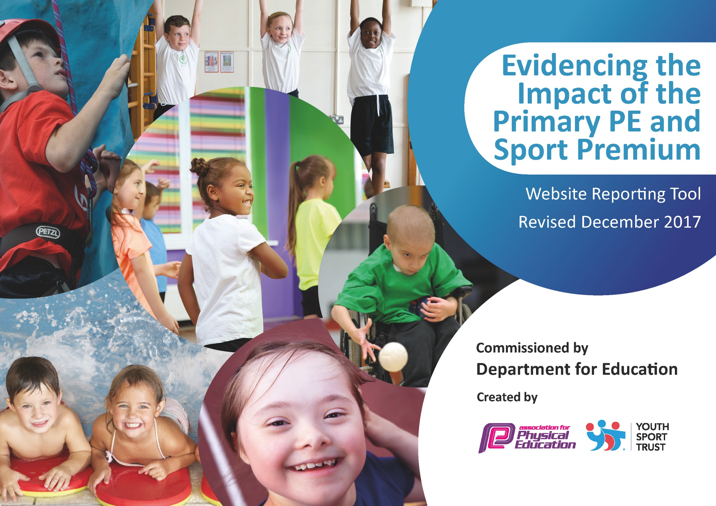

Schools must use the funding to make additional and sustainable improvements to the quality of PE and sport they offer. This means that you should use the Primary PE and Sport Premium to:

- develop or add to the PE and sport activities that your school already offers
- build capacity and capability within the school to ensure that improvements made now will benefit pupils joining the school in future years

Please visit gov.uk for the revised DfE guidance including the 5 key indicators across which schools should demonstrate an improvement. This document will help you to review your provision and to report your spend. DfE encourages schools to use this template as an effective way of meeting the reporting requirements of the Primary PE and Sport Premium.

We recommend you start by reflecting on the impact of current provision and reviewing the previous spend.
Under the Ofsted Schools Inspection Framework, inspectors will assess how effectively leaders use
the Primary PE and Sport Premium and measure its impact on outcomes for pupils, and how effectively governors hold them to account
for this.

Schools are required to publish details of how they spend this funding as well as on the impact it has on pupils’ PE
and sport participation and attainment.
We recommend regularly updating the table and
publishing it on your website as evidence
of your ongoing review into how you are using the money
to secure maximum, sustainable impact. To see an example of how to complete the table please click HERE.

Support for review and reflection - considering the 5 key indicators from DfE, what development needs are a priority for your setting and your students now and why? Use the space below to reflect on previous spend, identify current need and priorities for the future.

Key achievements to date: | Areas for further improvement and baseline evidence of need:
- We have previously prioritised the introduction of alternative sports e.g. golf, to encourage children who may not enjoy traditional school team sports. Although with facilities during school build restricted this will be difficult during 2017-18  - We continue to participate and be successful in local sporting tournaments. | - Extend competitive sport fixtures to all age groups rather than primarily year 6.  - Identify focus areas for further teacher CPD.  - Consider how we might introduce additional whole school activities e.g. Run/walk a Mile, with a view to introducing when new school build complete.  - Consider how to maintain current provision of sport in school, during school rebuild.  - Develop plans to Identify non-swimmers earlier in their school life and provide top up swimming lessons to ensure they meet national curriculum standards.

Meeting national curriculum requirements for swimming and water safety | Please complete all of the below*:
What percentage of your current Year 6 cohort swim competently, confidently and proficiently over a distance of at least 25 metres? | 86%  Class size: 21 (18 confident swimmers, 2 swimmers who can swim but are less confident, 1 non swimmers).
What percentage of your current Year 6 cohort use a range of strokes effectively [for example, front crawl, backstroke and breaststroke]? | 86%  As above
What percentage of your current Year 6 cohort perform safe self-rescue in different water-based situations? | 62%
Schools can choose to use the Primary PE and Sport Premium to provide additional provision for swimming but this must be for activity over and above the national curriculum requirements. Have you used it in this way? | Not yet but are considering it as part of future development plans.
As part of development
Action Plan and Budget Tracking
Capture your intended annual spend against the 5 key indicators. Clarify the success criteria and evidence of impact that you intend to measure to evaluate for students today and for the future.

Academic Year: 2017/18 | Total fund allocated: £ 17690 | Date Updated: 30th March 2018
Key indicator 1: The engagement of all pupils in regular physical activity – Chief Medical Officer guidelines recommend that primary school children undertake at least 30 minutes of physical activity a day in school |  |  |  | Percentage of total allocation:
 |  |  |  | 31%
School focus with clarity on intended impact on pupils: | Actions to achieve: | Funding allocated: | Evidence and impact: | Sustainability and suggested next steps:
Look to develop plans to morning routines to incorporate a regular fitness activity for all pupils when in new school.  All children encouraged to increase their fitness through monitoring and informal competitions.  Children are able to access high quality play and sport resources throughout lunch time break.  Provision of after school sporting clubs for children. | Wake up shake up activity – introduce September 2018  Whole school fitness testing days – booked through external PE provider for all children June 2018  Whole run a mile (as part of inter-house cross-country competition) – booked for March 2018. Run by external PE provider.  KS1 and KS2 school sports day – booked for July 2018. Run by external PE provider.  Inter-house sporting tournaments for all children. Football, netball and cricket booked for spring and summer term 2018. Run by external PE provider.  Purchase of new equipment for use at lunchtime.  Sports HLTA to organize weekly challenge. Board purchased to highlight challenges  Wide variety of after school clubs, catering for different sporting interests. | £250 to include purchase of resources and staff training ready for September start  £800 for external and internal staff  £400 for external and internal staff  £800 for external and internal staff  £1200 for external and internal staff  £800 new lunchtime equipment  and boards  £1200 external staff | To be monitored in Autumn 2018 | Look to introduce run/walk-a-mile when school build finished  Look to introduce more sport in 2018-19 so at least half-termly  Year 6 trained by HLTA to lead and organize activities
Key indicator 2: The profile of PE and sport being raised across the school as a tool for whole school improvement |  |  |  | Percentage of total allocation:
 |  |  |  | 2%
School focus with clarity on intended impact on pupils: | Actions to achieve: | Funding allocated: | Evidence and impact: | Sustainability and suggested next steps:
Ensure all children are aware of the importance of a healthy lifestyle, including both diet and regular exercise.  Pupils are aware of sporting activities and achievements across the school. | Introduce a healthy eating week when in new school  Sports noticeboard regularly updated with photographs and results. All participants in sporting fixtures receive a certificate of participation. | None for this academic year (planning time)  £300 for staff organising | Healthy eating week is booked for October/November 2018 and will include a Smoothie bike, assemblies and lunch audits.  Greater visibility and celebration of our sporting achievements. | Get children to write reports for events to go on school website

Key indicator 3: Increased confidence, knowledge and skills of all staff in teaching PE and sport |  |  |  | Percentage of total allocation:
 |  |  |  | 12%
School focus with clarity on intended  impact on pupils: | Actions to achieve: | Funding  allocated: | Evidence and impact: | Sustainability and suggested  next steps:
Ensure all staff are confident in teaching and delivering high quality PE resulting in higher quality learning. | Carry out an audit of teacher’s confidence and knowledge in the key curriculum areas (gym, dance, athletics and games).  Ensure all teachers are using and familiar with the relevant PE scheme purchased in previous year.  Get local sports personalities to lead school assemblies – Exeter City FC, Exeter Chiefs | £600 release time  £1500 for coaching and CPD through external provider | Audit distributed awaiting collection and analysis | Ensure staff training takes place for gymnastics and dance with new facilities in new school
Key indicator 4: Broader experience of a range of sports and activities offered to all pupils |  |  |  | Percentage of total allocation:
 |  |  |  | 34%
School focus with clarity on intended  impact on pupils: | Actions to achieve: | Funding  allocated: | Evidence and impact: | Sustainability and suggested  next steps:
Additional achievements:  Introduce all pupils to a range of alternative sports. | 5/6 week programs in key stage 1 and 2 of different sports introducing different skills (possible activities limited this year by facilities during school build)  Offer Zumba club to all pupils | £6000 external staff |  | Survey of children during summer term to identify suggested sports when in new school with improved facilities
Key indicator 5: Increased participation in competitive sport |  |  |  | Percentage of total allocation:
 |  |  |  | 21%
School focus with clarity on intended  impact on pupils: | Actions to achieve: | Funding  allocated: | Evidence and impact: | Sustainability and suggested  next steps:
Continue to develop the children’s involvement in local sport tournaments by increasing the number and variety of sports and varying the pupils who compete. | Take part in at least eight inter school sporting tournaments throughout the academic year.  Reintroduce the after-school netball club | £200 new netball bibs  £200 new footballs  £500 fees for East Devon organizer  £1500 transport expenses  £1400 staff costs to accompany teams | During 2017 we have (to date)  Qualified to East Devon finals in Cross country at both Year 3/4 and 5/6  Participated in Exeter 6 a-side tournament  Won LLC TAG rugby tournament  Took part in LLC Netball tournament  Took part in year 1/2 Football tournament  Took part in TAG rugby tournament ran by external provider | During Summer term send teams to LLC Swimming Gala, East Devon Kwik Cricket tournament, host LLC Tennis, host Kwik Cricket tournament,  LLC Quad kids and LLC rounders

